LIA Assurex S.A.L. - CTL FORWARDING S.A.R.L. - Damaged Marble Cargo

ULA reference: ULA-2026-0010 - 1v1
Applicant's Name: LIA Assurex S.A.L.
Assured's Name: CTL FORWARDING S.A.R.L
Policy No.: ZK-MAA-0104947
31 August 2026


It’s about time you receive the quality of service and expertise your firm deserves.
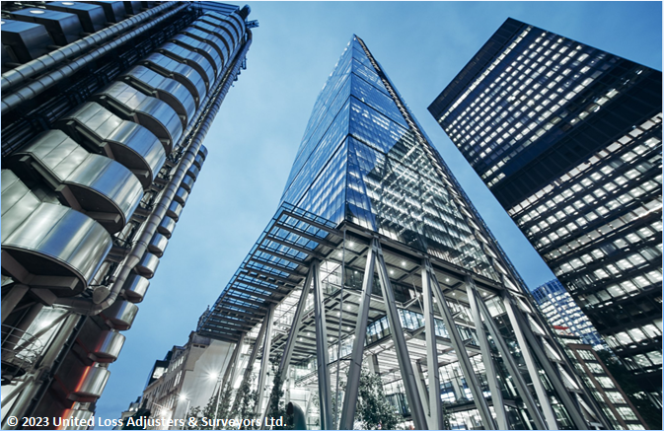

Document Control Page
Written by: | Reviewed by: | Approved by:
Tony Lahoud | To be assigned | To be assigned
Designation: | Designation: | Designation:
Claims Handler | Claims Director / Technical Reviewer | Director / Chartered Adjuster
Signature (Approver)
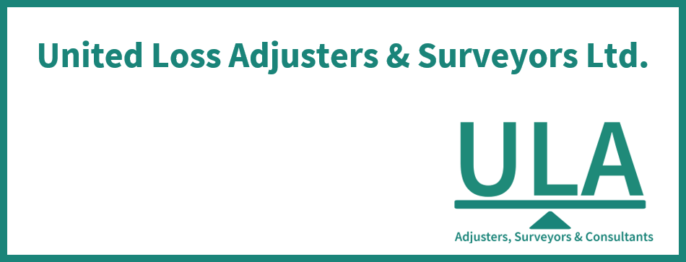
This survey and its issued report were completed without prejudice to all rights of parties concerned.
Date of approval
Pending professional approval

Version History | Date of issue | Reason for Revision
1 | 31 August 2026 | Issued for professional review
The contents of this report are for the confidential information of the client
This survey and its issued report were completed without prejudice to all rights of parties concerned and its concluded adjustment is in accordance with the terms and conditions of the relevant insurance policy.
Report Summary
At the request of LIA Assurex S.A.L. (the Insurer / Applicant), ULA was requested to investigate a Marine Cargo (Non-Reefer) claim concerning CTL FORWARDING S.A.R.L. (the Assured), establish the circumstances and extent of the reported loss, and review the replacement-cost claim under the policy. The insured interest is marble tiles and slabs.
In brief, Table 1 records CTL FORWARDING S.A.R.L. as the Assured, CHOUCAIR GROUP SAL as the house-B/L shipper, marble tiles and slabs as the insured interest, movement from Beirut, Lebanon to France, and Policy No. ZK-MAA-0104947.
Assured's / Shipper's Name | CTL FORWARDING S.A.R.L. (Assured); CHOUCAIR GROUP SAL (house-B/L shipper)
Consignee's Name | DIMA DEBS ARCHITECTURE (house-B/L consignee); CARGOTRANS GLOBAL FORWARDING (master-B/L consignee)
Insurance Policy | No. ZK-MAA-0104947  Insured Value / Limit: EUR 87,892.51  Basis of Valuation: Invoice value, subject to invoice reconciliation  Deductible / Excess: 10% of claim value, minimum EUR 750.00

In our opinion,
- The replacement quotation totals EUR 5,865.44. It cannot yet be stated as fair & reasonable because final claim presentation, VAT recoverability, coverage and all required adjustment inputs are not fully established.
- The proximate cause of loss is not expressly established as a source fact; the observed crate-frame collapse and marble breakage are compatible with loss of restraint, cargo movement or handling impact, subject to the alternative causes and evidence gaps stated below.
- Cover advice: ICC(A), the professional-packing warranty, the preliminary-survey warranty, the clean-B/L warranty, the under-deck/container-vessel provision and the deductible must be applied to the established facts. Packing adequacy and preliminary-survey compliance remain unresolved; final cover remains subject to professional review and approval.
- Liable-party position: No liable party is established from the reviewed evidence. Any recovery against carrier, haulier, packer or other interests requires final carriage documents, custody-specific causation, timely notice and survey evidence, and review of applicable limitation and time-bar provisions.
- We confirm having sighted the originals of all documents customarily submitted in support of a claim of this nature and remain at Insurers disposal for further instructions.
Report and adjustment note
At the request of LIA Assurex S.A.L. (the Insurer / Applicant), ULA was requested to investigate a Marine Cargo (Non-Reefer) claim concerning CTL FORWARDING S.A.R.L. (the Assured), establish the circumstances and extent of the reported loss, and review the replacement-cost claim under the policy. The insured interest is marble tiles and slabs. This report records the evidence reviewed, causal assessment and provisional adjustment position; supporting documents are retained and transmitted separately.
Table 1 - Summary and salient details
Applicant's Name | LIA Assurex S.A.L.
Assured's Name | CTL FORWARDING S.A.R.L
Insurance Policy | No. ZK-MAA-0104947  Insured Value / Limit: EUR 87,892.51  Transit Scope: Sea, Beirut to France  Basis of Valuation: Invoice value, subject to invoice reconciliation  Clauses / Basis of Cover: ICC(A) and stated endorsements  Material Warranties: Preliminary survey at customs warehouse where apparent or suspicious damage exists; clean B/L; professional and suitable packing; new items; vessel class; under-deck carriage subject to the container-vessel exception  Deductible / Excess: 10% of claim value, minimum EUR 750.00
Incoterm / Terms of sale | Not established from the reviewed evidence
Transport Document | Master B/L BRT0311410 (DRAFT); House B/L CTL/BEY/2026-14 (DRAFT). The house B/L names CMA CGM TOKYO while the master B/L and carrier tracking identify CMA CGM NANSHA; final transport documents and the vessel discrepancy require confirmation.
Shipper's Name | CHOUCAIR GROUP SAL
Consignee's Name | DIMA DEBS ARCHITECTURE
Cargo / Commodities | BSIU3470622; Marble tiles and slabs
Origin / Destination | Beirut, Lebanon / France
Carrying Vessel / Carrier | CMA CGM NANSHA / voyage 0NVMHN1MA in the master B/L and carrier tracking; CMA CGM TOKYO in the draft house B/L (conflict requiring confirmation); carrier CMA CGM S.A.
Cargo Arrival / Delivery Date | Discharged 2026-07-18; Arrived 2026-07-18; Empty container returned 2026-07-24

INTEREST INSURED & RELEVANT CONDITIONS OF INSURANCE POLICY
Marble tiles and slabs was documented for transit from Beirut, Lebanon to France under Policy No. ZK-MAA-0104947.

SHIPMENT ROUTING
Beirut → Le Havre (CMA CGM NANSHA 0NVMHN1MA) → Paris inland by Sterna

SURVEYOR NOTES
- Material chronology. 01-Jun-2026: commercial invoice issued. 03-Jun: empty container gated out. 05-Jun: ready to load. 09-Jun: policy inception. 10-Jun: policy issued. 16-Jun: master B/L records shipped on board. 17-Jun: carrier tracking records departure from Beirut. 18-Jul: arrival and discharge at Le Havre. 22-Jul: gate-out to consignee. 23-Jul: reported inland delivery in Paris. 24-Jul: empty return at Rouen. 10-Aug: replacement quotation issued.
- Shipment and condition. Container BSIU3470622, seal M1813527, carried 14 boxes and one pallet of marble/resin cargo. The photographs show breakage and chipping affecting several marble types and a crate frame that appears collapsed or fallen. The available documents do not establish the precise damage-discovery time, a custody-specific mechanism, or a complete joint-survey and notice record.
Description | Boxes / Quantity | Packing
Marble slabs and tiles; physical breakage and chipping reported | Shipment: 14 boxes and 1 pallet. Replacement quotation: 11.70 SQM Arabescato Vagli, 3.956 SQM Travertino Romano and 5.664 SQM Travertino Tortora. | Crated / boxed cargo; detailed crate construction, blocking, bracing and void filling are not established from the reviewed evidence

CAUSE OF LOSS
The proximate cause of loss is not expressly established as a source fact; the available evidence supports the qualified professional assessment set out below.
The photographs show breakage and chipping across several marble slabs and strips, together with a crate frame that appears collapsed or fallen inside container BSIU3470622. The available damage record identifies damage but does not establish the physical mechanism or the custody stage at which it occurred.
In our opinion, the observed condition is compatible with loss of restraint or crate failure followed by cargo movement or handling impact. Alternative explanations remain inadequate packing or void filling, pre-shipment weakness or existing damage, and impact during port handling, inland transport or unloading.
A stronger conclusion requires the final master and house bills of lading, stuffing and loading-condition evidence, delivery-condition and preliminary-survey records, crate design and lashing details, and complete notice, joint-survey and damage documentation linking the condition to a specific custody stage.

RELEVANT POLICY WARRANTIES & CONDITIONS
Material warranties and conditions include professional and suitable packing, preliminary survey at the customs warehouse where apparent or suspicious damage exists, a clean bill of lading, vessel-class requirements and under-deck carriage subject to the container-vessel exception. The photographs raise a packing-adequacy issue, while preliminary-survey compliance is not established. The master B/L is marked DRAFT, and the master/house vessel discrepancy requires confirmation from final transport documents.
No warranty breach, exclusion, coverage or liability conclusion is made without the complete operative wording and current-claim evidence needed to map the provision to the established facts.

ADEQUACY OF THE INSURED VALUE
Whether the invoice values are adequately insured and whether there is underinsurance cannot be established from the available evidence because the invoice records a numerical total of EUR 87,982.51 but a conflicting amount in words, while the documented insured value is EUR 87,892.51. The invoice amount and applicable valuation basis require professional reconciliation.

APPOINTMENT OF ASSESSORS
To date, it is understood that the Assured had not appointed a loss assessor to act on their behalf.

CLAIM PRESENTED ON THE POLICY & ADJUSTMENT
Replacement quotation SAL-QTN-2026-00901 totals EUR 5,865.44, including EUR 581.26 VAT. It evidences proposed replacement and packing costs but does not by itself establish that every item is an incurred, presented or recoverable claim cost.
The quotation arithmetic reconciles to EUR 5,865.44. Under the policy wording, 10% of that amount is below the EUR 750.00 minimum deductible; accordingly, EUR 750.00 is the applicable provisional deductible if the quoted items and VAT are accepted as covered claim costs.
Commercial invoice SA/2026/470 records a numerical gross total of EUR 87,982.51, while its amount in words is inconsistent. The shipment invoice is valuation context and is not substituted for the damaged-item claim.
Final indemnity remains subject to confirmation of the Assured's presented claim, VAT recoverability, damage scope, policy application, packing and preliminary-survey issues, and any further supported adjustment.
Table 2 - Claim presented by the Assured & Adjustment
Description | Quantity damaged | Unit Price in EUR | Adjusted Claim Value in EUR
Replacement: Arabescato Vagli 2CM Slabs 300x195 – 11.70 SQM @ EUR 280.00 | 11.70 SQM | EUR 280.00 | EUR 3,276.00
Replacement: Travertino Romano 2CM Slabs 293x135 – 3.96 SQM @ EUR 145.00 | 3.96 SQM | EUR 145.00 | EUR 573.62
Replacement: Travertino Tortora 2CM Slabs 295x192 – 5.66 SQM @ EUR 165.00 | 5.66 SQM | EUR 165.00 | EUR 934.56
Packing fees including fumigation (600 USD equivalent) – 1 Nos @ EUR 500.00 | 1 Nos | EUR 500.00 | EUR 500.00
VAT 11% on replacement quotation subtotal EUR 5,284.18 | Not applicable | Not applicable | EUR 581.26
Replacement Quotation Total ----------------------------------------------- EUR 5,865.44
Less, Provisional Policy Deductible ------------------------------------ (EUR 750.00)
Provisional Amount after Deductible ------------------------------------- EUR 5,115.44
Concluded Indemnity ------------------------------------------------------ Not established from the reviewed evidence
A concluded indemnity is not stated pending confirmation of claim presentation, VAT recoverability, coverage and professional approval.

CONCLUSION
In our opinion,
- The replacement quotation totals EUR 5,865.44. It cannot yet be stated as fair & reasonable because final claim presentation, VAT recoverability, coverage and all required adjustment inputs are not fully established.
- The proximate cause of loss is not expressly established as a source fact; the observed crate-frame collapse and marble breakage are compatible with loss of restraint, cargo movement or handling impact, subject to the alternative causes and evidence gaps stated below.
- Cover advice: ICC(A), the professional-packing warranty, the preliminary-survey warranty, the clean-B/L warranty, the under-deck/container-vessel provision and the deductible must be applied to the established facts. Packing adequacy and preliminary-survey compliance remain unresolved; final cover remains subject to professional review and approval.
- Liable-party position: No liable party is established from the reviewed evidence. Any recovery against carrier, haulier, packer or other interests requires final carriage documents, custody-specific causation, timely notice and survey evidence, and review of applicable limitation and time-bar provisions.
- We confirm having sighted the originals of all documents customarily submitted in support of a claim of this nature and remain at Insurers disposal for further instructions.

Enclosure to this report

Outstanding Documents

Appendix A - Photographs
Photographs show the marble cargo, its crates and packing, identification details, and the observed breakage and chipping.
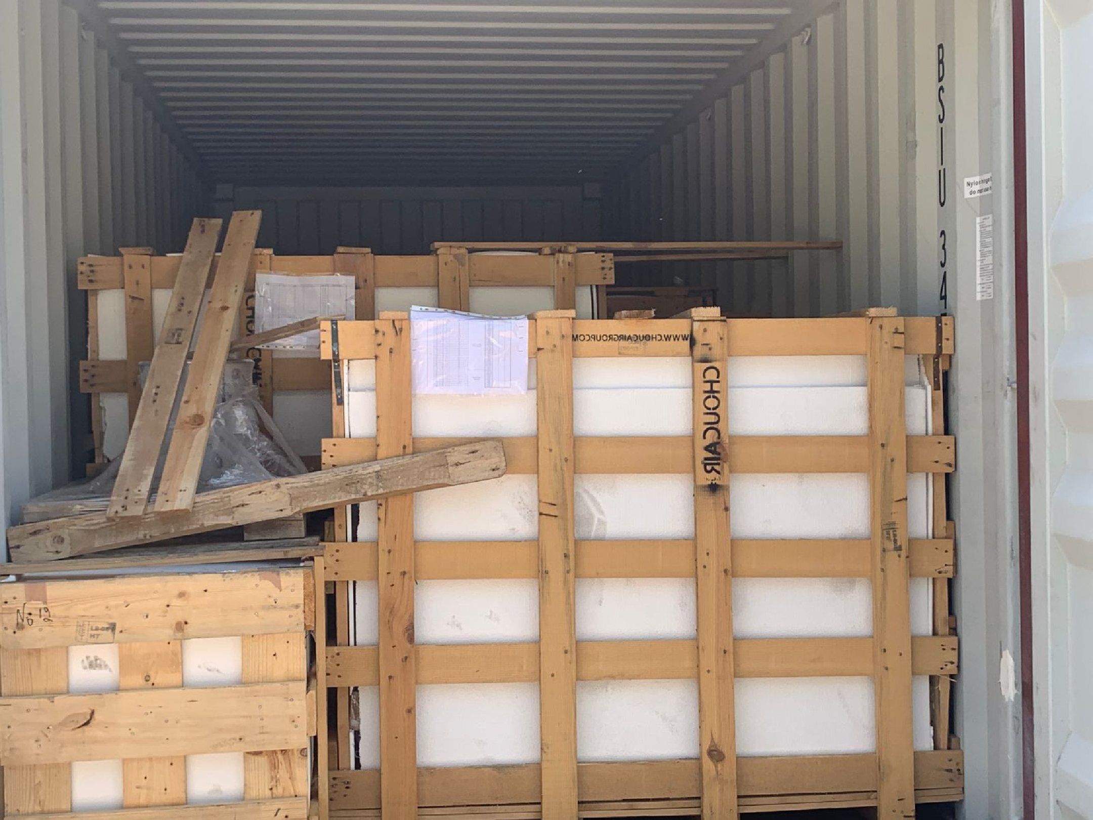 | 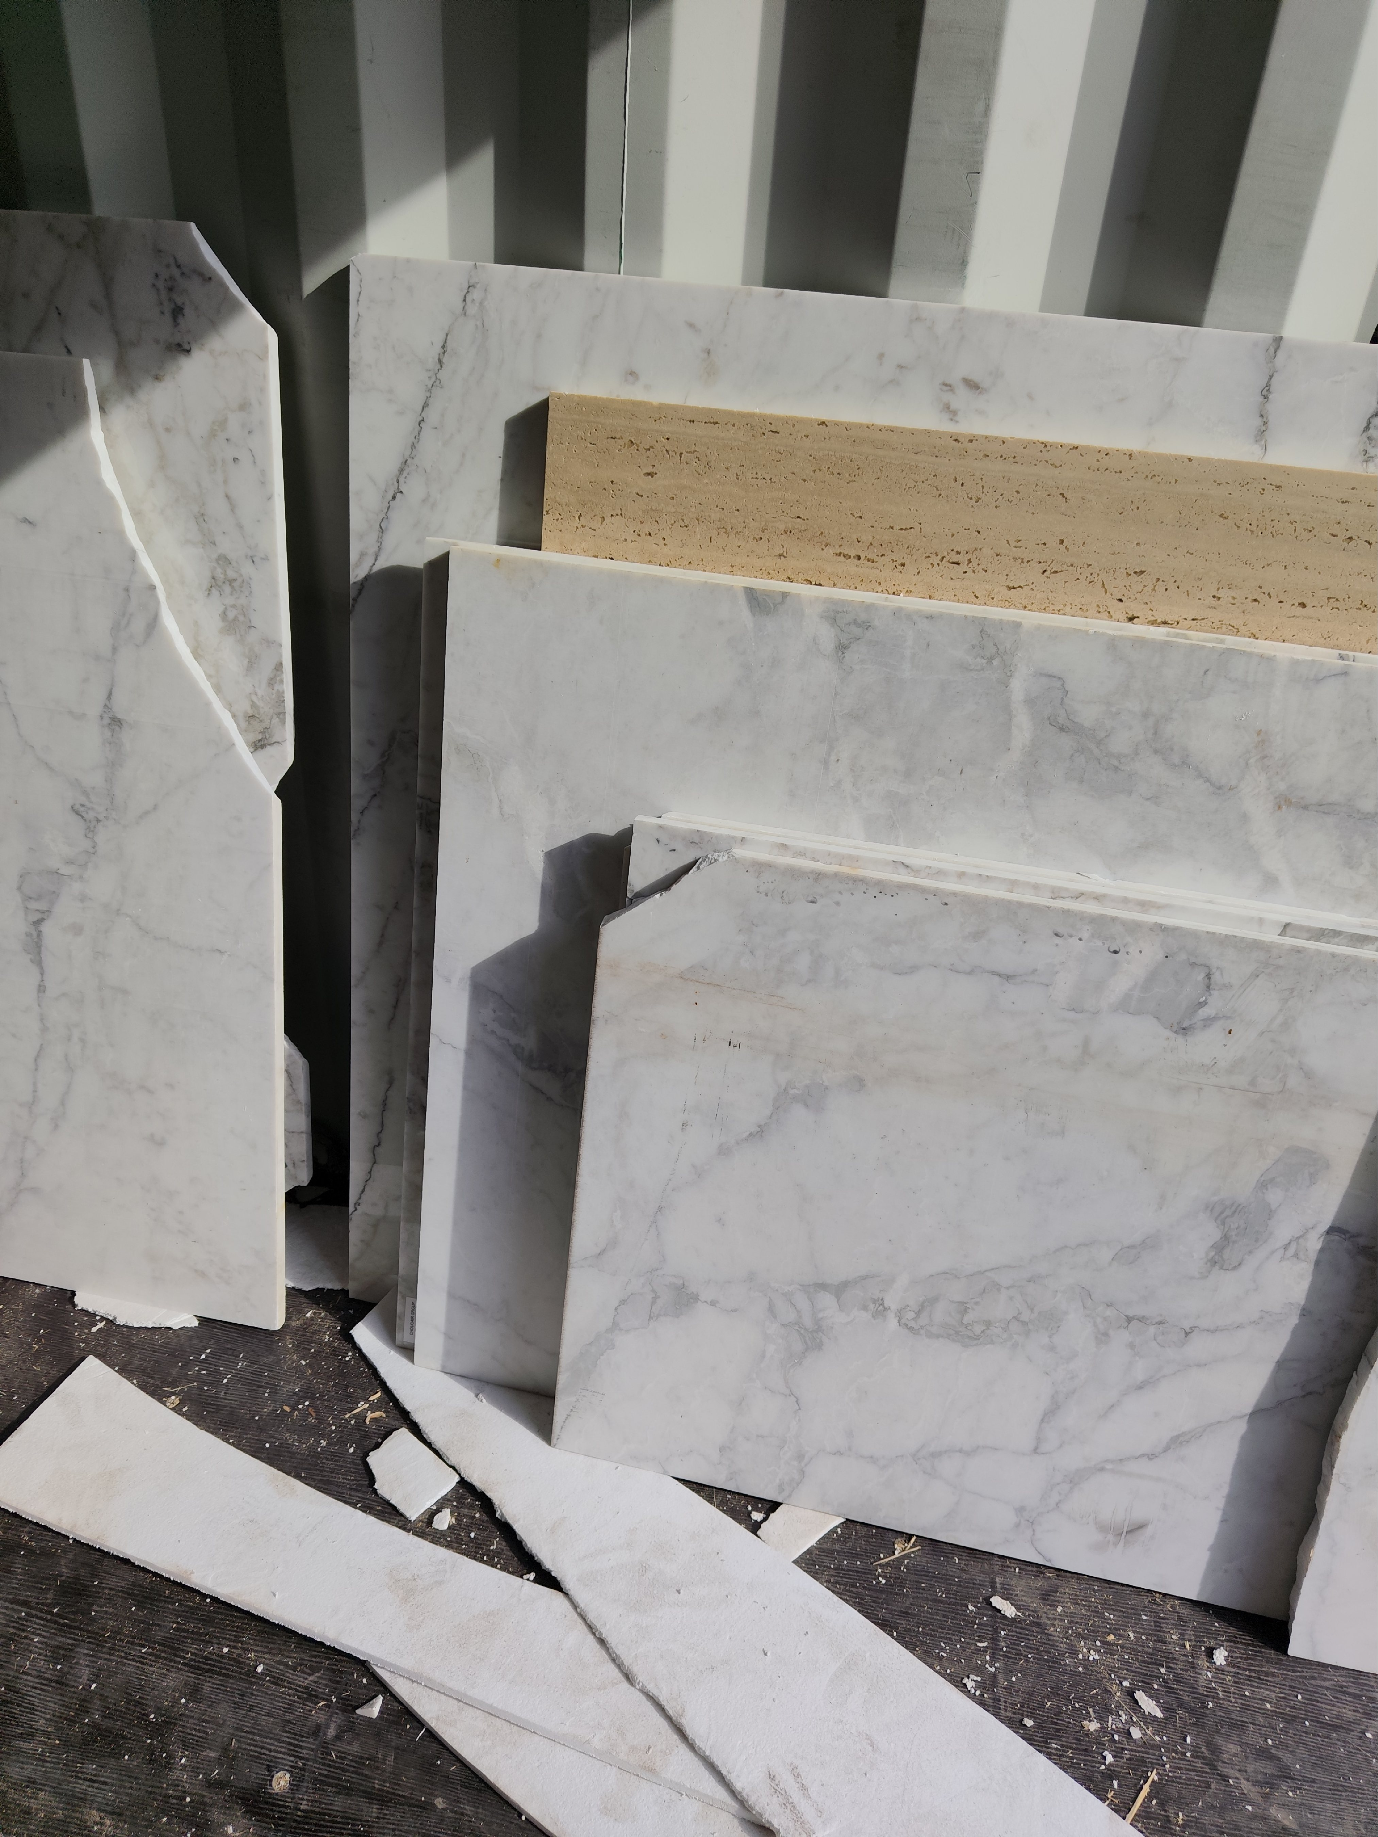
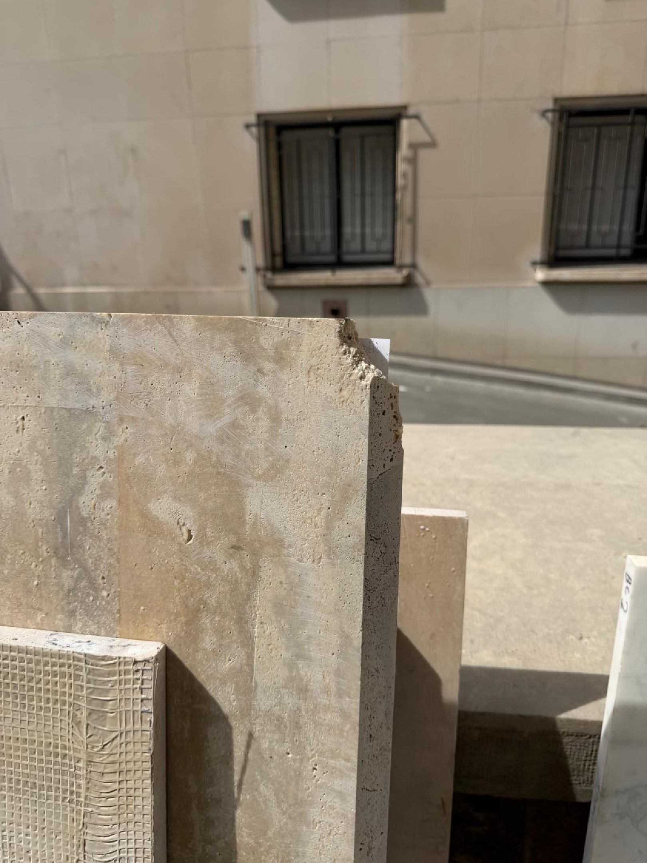 | 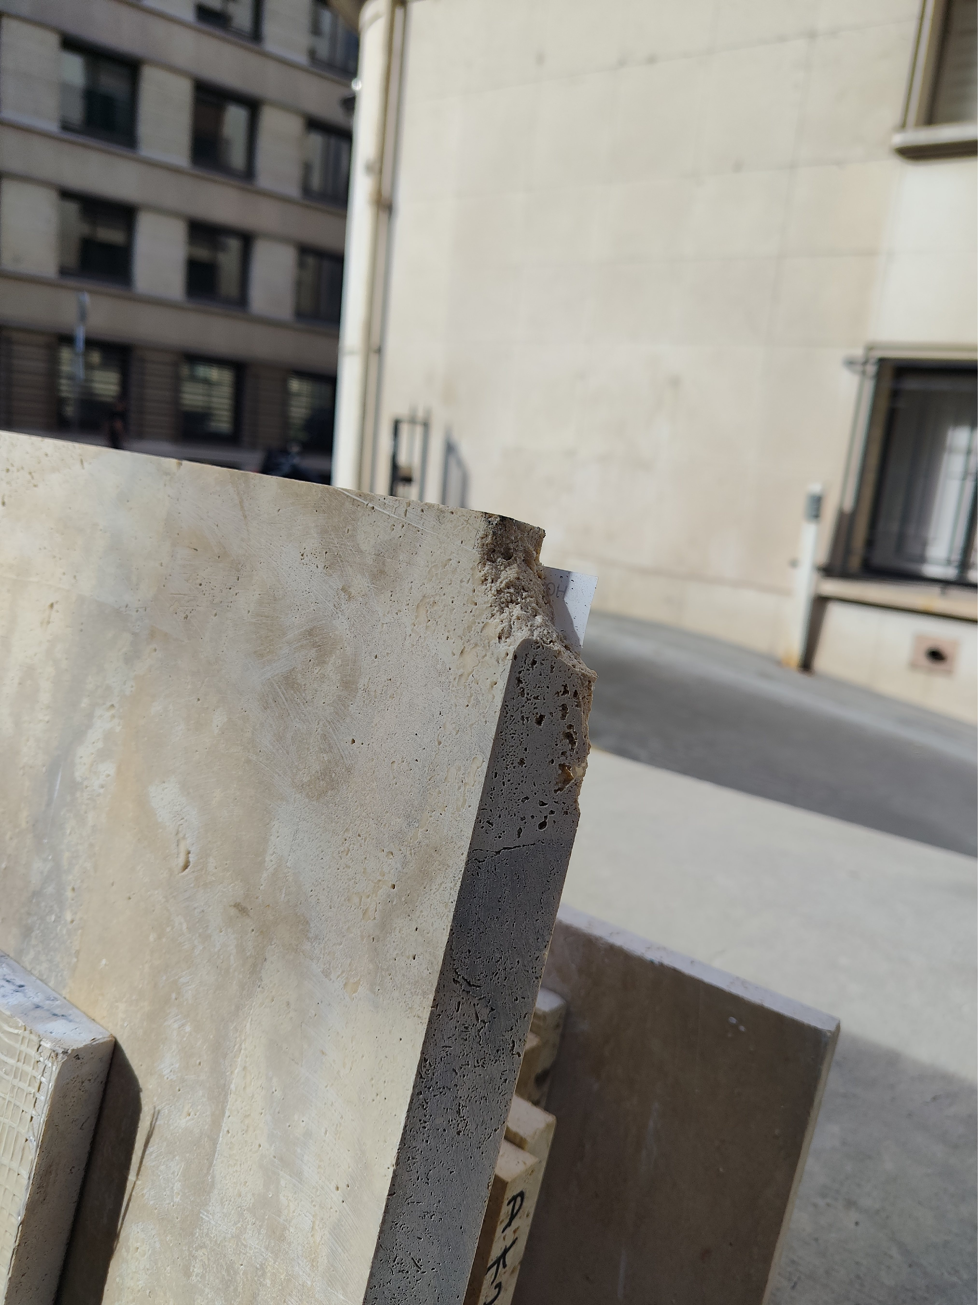

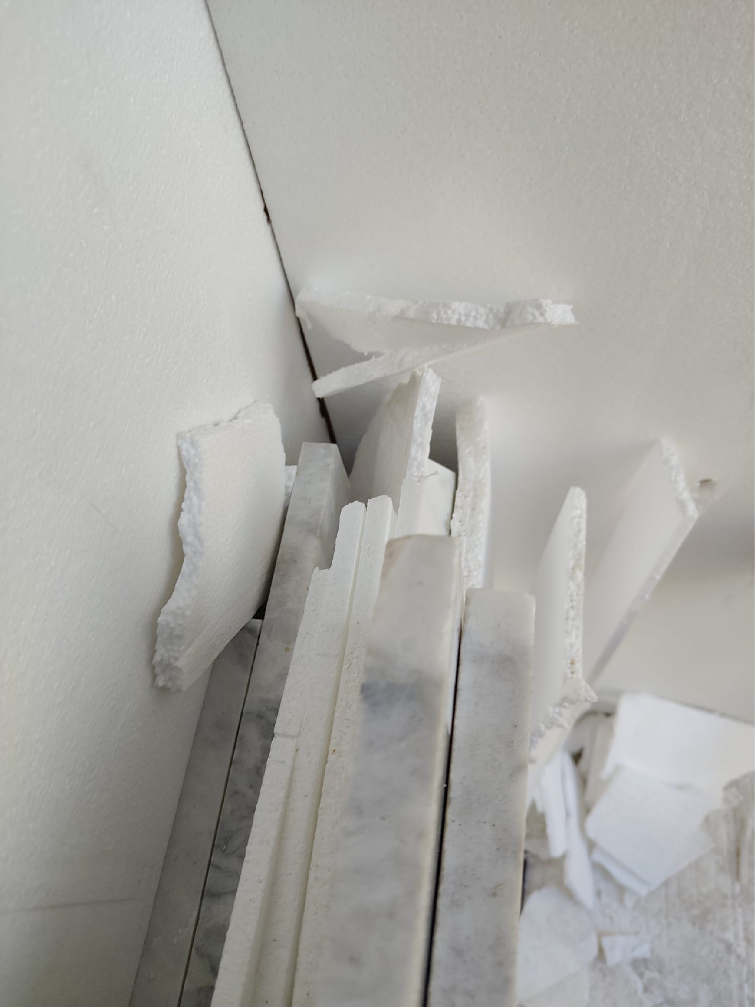 | 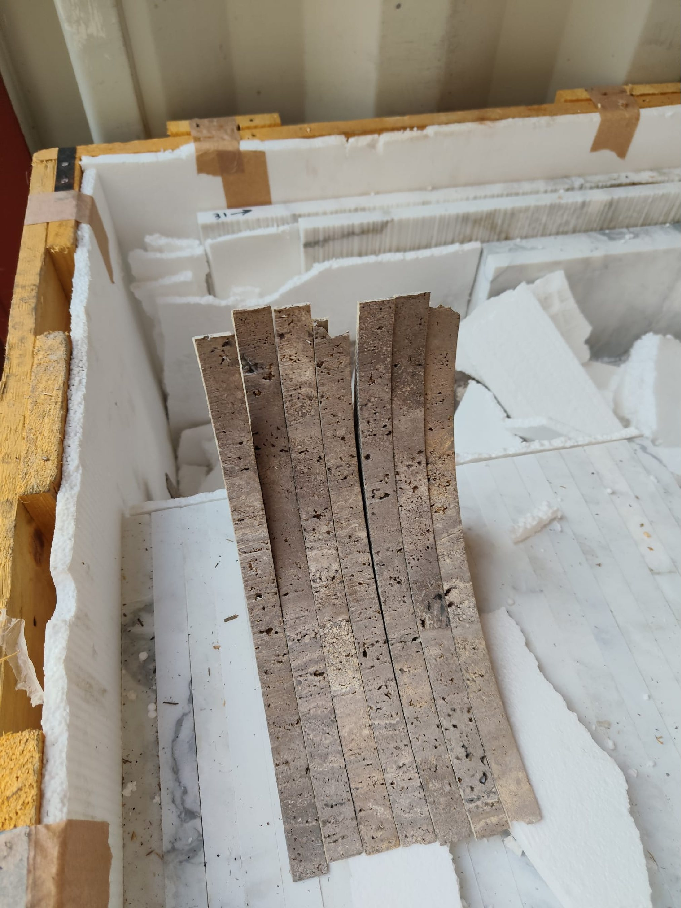
About ULA
United Loss Adjusters and Surveyors (ULA) is a leading international provider of Adjusters, Surveyors, Solicitors and Consultants, offering unrivalled technical and legal solutions with exclusive access to the London Market's leading specialists.
Founded in 2002, with strategic head offices in the Middle East and the United Kingdom, today ULA is the strategic ally of a world-leading legal firm (with offices in over 60 major countries) and the correspondent for a number of global technical service providers (with offices in 140+ countries), with principals including but not limited to Insurers, Reinsurers, Brokers, P&I clubs, Ship Owners, Shipyards and Agencies.
Lines of business:
- Insurance & Re-insurance
- Claims solutions and loss adjusting across all major lines: aviation, cargo, marine, property, fine arts and special risks claims
- Cargo & Containers
- Marine & Offshore
- Global Claim Recoveries & Legal Support
Our team:
Our team of qualified professionals experienced in the fields of Marine, Insurance, Finance, Engineering and Law known and respected for their integrity and credibility. Supported by a highly mobile team strategically positioned where our services are needed, we are always available on short notice to deal promptly with your queries. ULA is independent to the core and can be trusted to express unbiased views, and is not influenced by stakeholders.
ULA’s team members are recognised:
- Chartered Engineers
- Consultants
- Inspectors & Auditors
- Insurance & Re-Insurance Underwriters
- Loss & Average Adjusters
- Master Mariners & Chief Engineers
- Naval Architects, Marine & Offshore Engineers
- Solicitors
- Sworn Surveyors
ULA’s team members are also recognised members of the following international institutions:
- The Association of Average Adjusters (AAA)
- The Bar Council of England and Wales
- The Chartered Insurance Institute (CII)
- The Chartered Institute of Loss Adjusters (CILA)
- The European Federation of Loss Adjusting Experts (FUEDI)
- The Institute of Fire Engineers (IFE)
- The Institute of Marine Engineering, Science and Technology (IMarEST)
- The UK Engineering Council
- The Royal Institute of Naval Architects (RINA)
- The International Institute of Marine Surveying (IIMS)
- The Royal Institute of Chartered Surveyors (RICS)

Contact person
United Kingdom: 71-75 Shelton Street, Covent Garden | London, England - WC2H 9JQ
Middle East: Mina Tower, Ain Warda Street | Beirut, Lebanon - WG2G+5CX

Registered name United Loss Adjusters and Surveyors Ltd.

24/7 Contacts & Claim Support – T: +44 (0) 20 3287 3326 | M/WhatsApp: +44 (0) 7 375 110 573
Office E: mailto:claims@unitedlossadjusters.com
W: https://www.unitedlossadjusters.com/



